**PROJECT DEVELOPMENT PHASE**

**Date:** 18-06-2025

**Team ID:** LTVIP2025TMID28970

**Project Name**: Garage Management System – (Developer)

**Maximum Marks:** *(To be filled by evaluator)*

**1. OVERVIEW**

This document captures the technical deliverables implemented as part of the **Garage Management System** project in Salesforce. It includes the details of custom configurations, automation logic, sample datasets, and screenshots of functional outputs. The goal is to demonstrate the executable components of the solution and provide visual evidence that the core functionality has been correctly built and deployed.

This section serves as a proof of execution, showcasing that the development aligns with the problem statement, solution design, and project objectives defined in the earlier phases for the efficient management of a vehicle service center.

**2. REQUIRED PROJECT FILES**

**A. Custom Objects and Their Roles**

1. **Customer_Details__c**
   * **Purpose**: Stores comprehensive information about vehicle owners/customers, including their name, contact number, email address, physical address, and any relevant preferences or notes.
   * **Usage:** This object serves as the central point for all customer-related data.
   * **Key Fields :**
     + **Phone_number__c**
     + **Gmail__c**

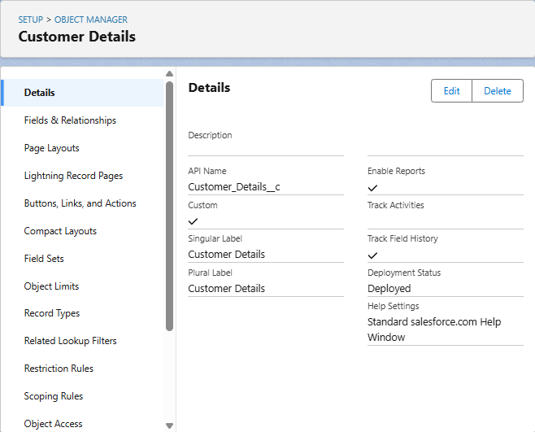

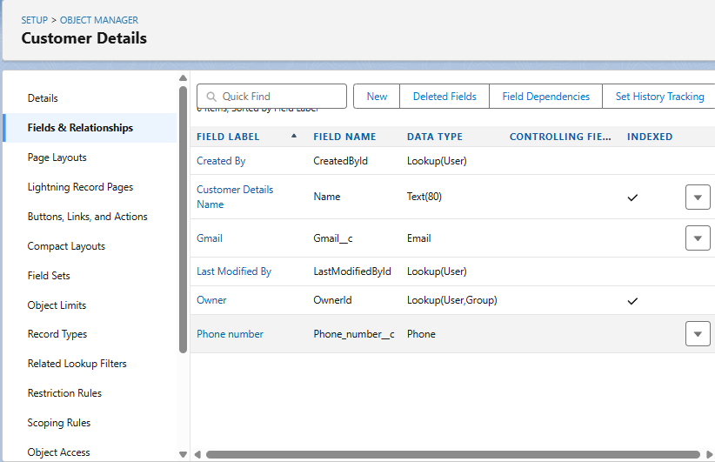

1. **Appointment__c**
   * **Purpose**: To manage and track scheduled service appointments for vehicles. This object records the date, time, type of service requested, and links to the customer and their vehicle, enabling efficient scheduling and resource allocation for the garage.
   * Usage: This object is crucial for front-desk operations and service advisors to manage the garage's schedule
   * Key Fields:
     + Customer_details__c (lookup)
     + ­Maintenance_service__c
     + Repairs__c
     + Replacement_parts__c
     + Appointment_Date__c
     + Service_Amount__c
     + Vechile_number_plate__c

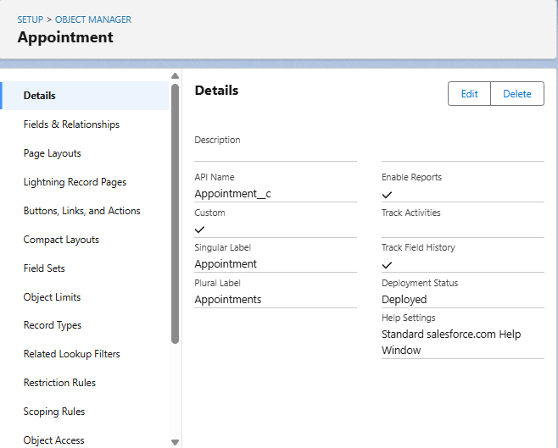

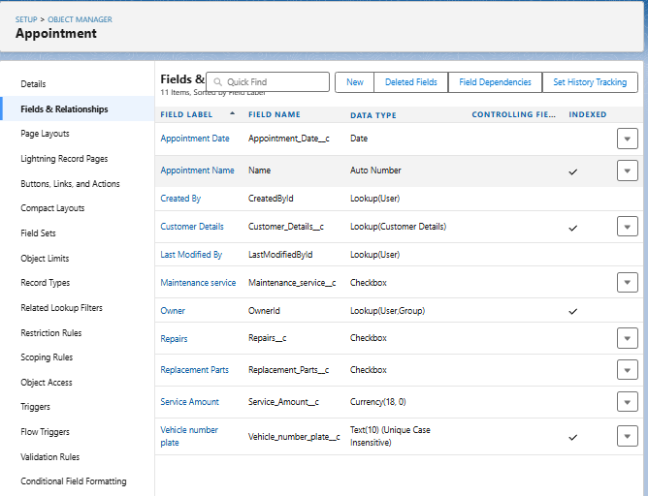.

1. **Service_records__c**
   * Purpose: To maintain a comprehensive historical log of all services performed on a specific vehicle.
   * **Usage:** This object is primarily used for historical tracking, reporting on vehicle service history, and supporting customer inquiries about past work.
   * Key Fields:
     + Quality_Check_Status__c
     + Appointment__c (lookup)
     + Service_Status__c
     + Service_date__c

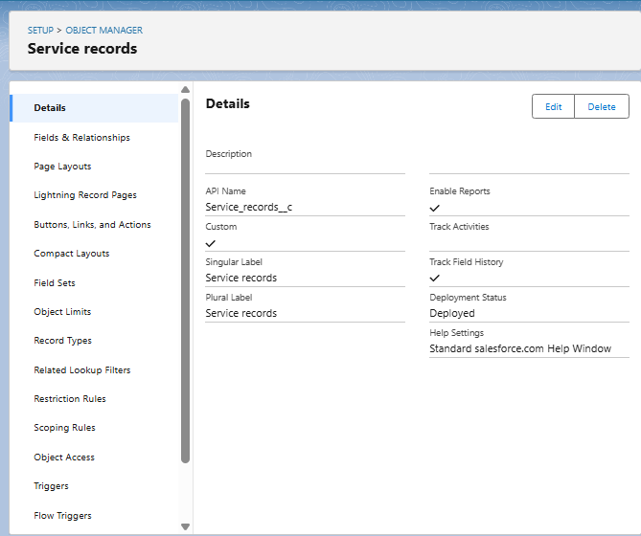

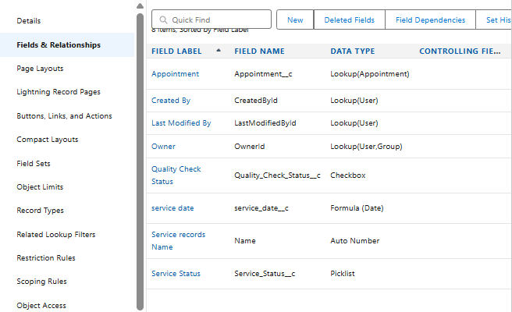

1. **Billing_details_and_feedback__c**
   * Purpose: This object serves a dual role: primarily to store the detailed financial aspects of a service (invoice lines, amounts, payment status) and secondarily to capture customer feedback related to that specific service or billing experience.
   * **Usage:** This object is used by billing clerks and service advisors to track financial transactions and customer payment status.
   * Key Fields:
     + Service_records__c (lookup)
     + Payment_Paid__c
     + Rating_for_service__c
     + Payment_Status__c

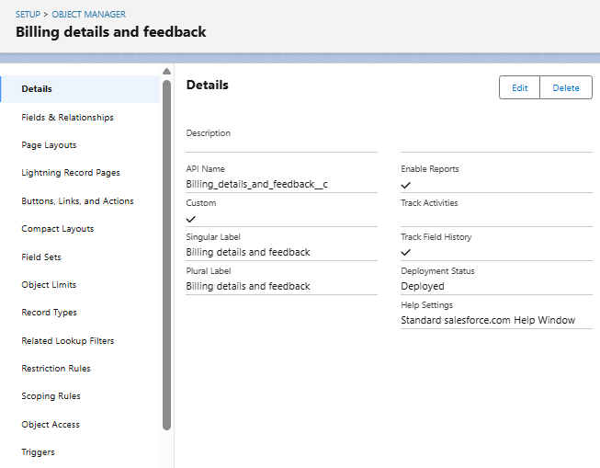

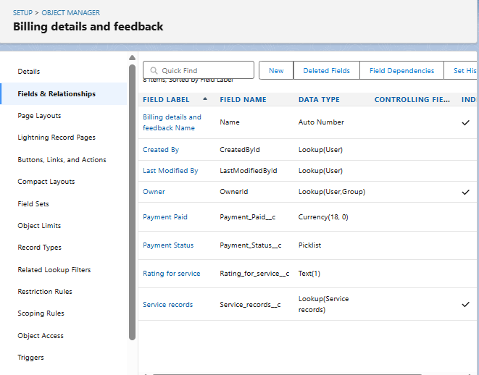

**B. AUTOMATION ELEMENTS**

The **Garage Management System** leverages Salesforce's automation capabilities to streamline business processes, reduce manual interventions, and enhance operational accuracy. The automation comprises Apex Triggers, Record-Triggered Flows, and Validation Rules, all tailored to meet the critical needs of an **automotive service and repair operations**.

**1. Apex Trigger –**

* **Name:** AmountDistributionHandler
* **Trigger Type:** Before Insert, Before Update
* **Description:**  
  This use case works for Amount Distribution for each Service the customer selected for the Vehicle
* **Core Logic:**

trigger AmountDistribution on Appointment__c (before insert, before update) {

     if(trigger.isbefore && trigger.isinsert || trigger.isupdate){

         AmountDistributionHandler.amountDist(trigger.new);

    }

}

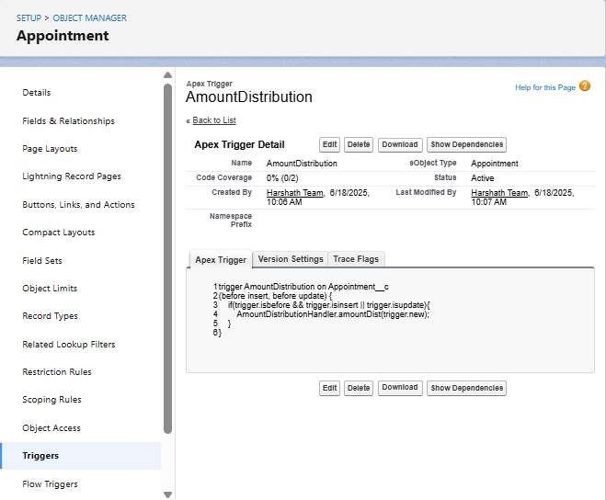

**2. Record-Triggered Flow –**

* **Flow Name:** Billing_Account_Flow
* **Trigger Event:** On Create or Update of a **Billing_details_and_feedback__c** record.
* **Flow Description:**  
  This Record-Triggered Flow is designed to automate key communication and data updates immediately after a service invoice is created or updated within the Garage Management System.
* **Email Template Sample Content:**
* Dear {!$Record.Service_records__r.Appointment__r.Customer_Name__r.Name},
* I hope this message finds you well. I wanted to take a moment to express my sincere gratitude for your recent payment for the services provided by our garage management team. Your prompt payment is greatly appreciated, and it helps us continue to provide top-notch services to you and all our valued customers.
* Amount paid : {!$Record.Payment_Paid__c}
* Thank you for Coming .

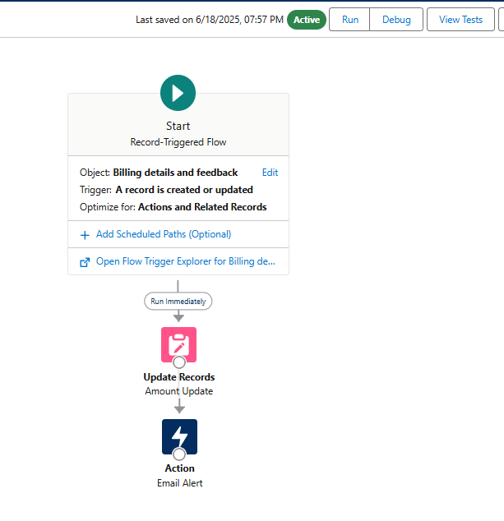

**3. Validation Rules –**

* **Validation Rule Name:** Vehicle
* **Associated Object:** Appointment__c
* **Formula Logic:**
* NOT(REGEX( Vehicle_number_plate__c , "[A-Z]{2}[0-9]{2}[A-Z]{2}[0-9]{4}"))
* **Error Message:**  
  "Please enter vaild number ”, select the Error location as Field and select the field as “Vehicle number plate”
* **Purpose:**
  + The purpose of this Validation Rule is to **enforce a specific, standardized format for vehicle number plates** when an **Appointment__c** record is being created or edited. It ensures that the **Vehicle_number_plate__c** field adheres to a predefined pattern, thereby **improving data quality and consistency** within the Garage Management System. This is critical for accurate vehicle identification, searching, and legal compliance.
* **Usage Scenario:**
  + **Data Integrity:**When a service advisor or any user attempts to save an Appointment__c record (or any record where Vehicle_number_plate__c is present and this rule is active), Salesforce will automatically check the value entered in the Vehicle_number_plate__c field against the specified regular expression (REGEX) pattern.
  + **Error Prevention:** If the entered vehicle number plate does *not* match the pattern

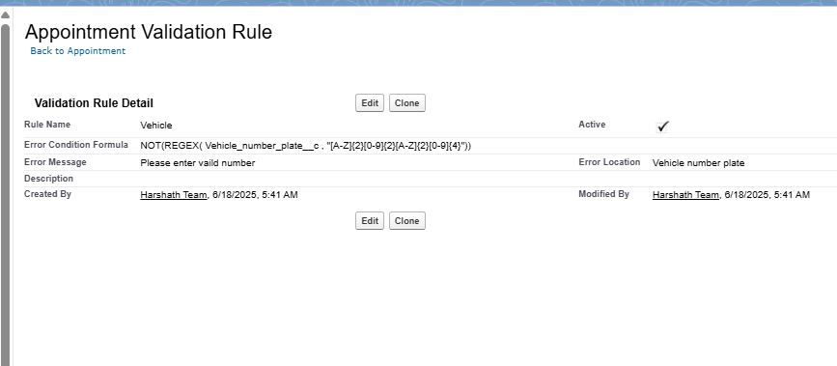

* **Validation Rule Name:** rating_should_be_less_than_5
* **Associated Object:** Billings_details_and_feedback__c
* **Formula Logic:**

NOT( REGEX( Rating_for_service__c , "[1-5]{1}"))

* **Error Message:**  
  " rating should be from 1 to 5”, select the Error location as Field and select the field as “Rating for Service”
* **Purpose:**
  + The purpose of this Validation Rule is to **ensure that the Rating_for_service__c field, which captures customer feedback on service quality, only accepts numerical input between 1 and 5 (inclusive).** This is crucial for maintaining the integrity and consistency of customer satisfaction data, enabling accurate analysis and reporting of service performance.
* **Usage Scenario:**
  + **Data Quality Enforcement:** When a user (e.g., service advisor, or even through an external customer survey integration if applicable) attempts to save a Billing_details_and_feedback__c record, this rule validates the Rating_for_service__c field.
  + **Preventing Invalid Input:** If the entered value for Rating_for_service__c is anything other than a single digit from 1 to 5 (e.g., "0", "6", "abc", or even "12"), the system will prevent the record from being saved

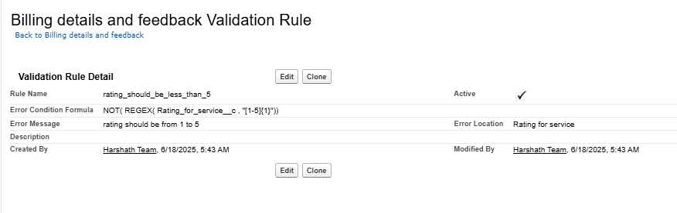

**4. Duplication Rules –**

* **Matching Rule Name:** Matching Customer details
* **Associated Object:** Customer_details__c
* **Matching Criteria:**

|  |  |
| --- | --- |
| **Field** | **Matching method** |
| Gmail | Exact |
| Phone Number | Exact |

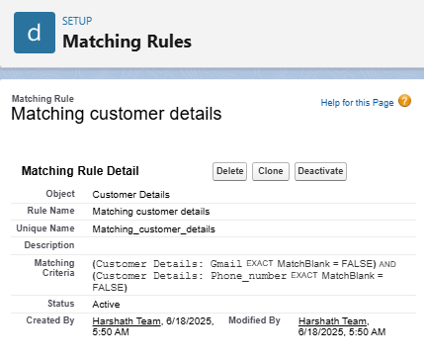

**C. UI COMPONENTS**

**A. Reports Configuration**

**Use Case:**

Monitor daily, weekly, or monthly revenue from services and parts. Analyze profitability by service type or mechanic.

**Activity 1: Create and Share a Report Folder**

**Description:** Set up a dedicated report folder and configure its sharing permissions for relevant user roles.

**Main Steps:**

1. Navigate to the **Reports** tab and click **"New Folder"**.
2. Label it "Garage Management Folder" and **Save**.
3. From the "All Folders" view, select the folder's dropdown, click **"Share"**, choose "Roles" -> "Manager", set "View" access, and **Share**.

**Activity 2: Create Custom Report Type**

**Description:** Define a custom report type to connect Customer__c with Appointment__c, Service_Record__c, and Billing_details_and_feedback__c for comprehensive service reporting.

**Main Steps:**

1. Go to **Setup** > **Report Types**.
2. Click **"New Custom Report Type"**.
3. Set **Primary Object** as Customer__c, label it "Service Information", set category to "Other Reports", and deploy.
4. Relate Appointment__c, Service_Record__c, and Billing_details_and_feedback__c as secondary objects and **Save**.

**Activity 3: Create Necessary Records for Testing**

**Description:** Populate your Salesforce Org with sample data across key objects to enable robust report testing.

**Main Steps:**

1. Create at least **10 records for each** of your main custom objects: Customer__c, Vehicle__c, Appointment__c, Service_Record__c, and Billing_details_and_feedback__c.
2. Ensure you **fill in all relevant fields** for each record with varied data to maximize report richness.

**Activity 4: Create a New Report and Visualize Data**

**Description:** Generate a new report using the custom report type, select key fields, group data for analysis, and add a visual chart.

**Main Steps:**

1. Go to the **Reports** tab and click **"New Report"**.
2. Select the "Service Information" report type from the "Other Reports" category.
3. Add Customer Name, Appointment Date, Service Status, and Payment Paid to **Columns**.
4. Group rows by Rating for Service and Payment Status.
5. Add a **Line Chart**, then **Save** the report as "New Service Information Report" to the "Garage Management Folder".

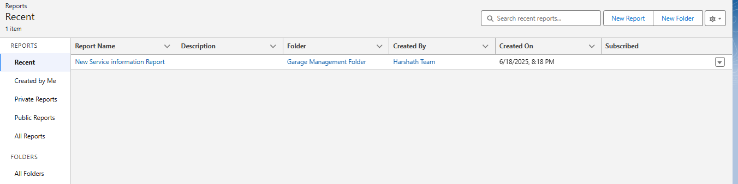

**D. Dashboards**

**Use Case:**

Displays total monthly revenue, revenue by service type (e.g., repairs vs. maintenance), average invoice value, and outstanding payments.

**Activity 1: Create and Share a Dashboard Folder**

**Description:** Set up and share a dedicated dashboard folder for garage analytics.

**Main Steps:**

1. **Create Folder:** Go to Dashboards tab > New Folder, name it "Service Rating Dashboard", and Save.
2. **Share Folder:** From "All Folders" dropdown, Share the new folder with "Roles" > "Manager" as "View" access.

**Activity 2: Create a Dashboard and Set Subscription**

**Description:** Build a new dashboard with a report component and schedule weekly email updates.

**Main Steps:**

1. **Create Dashboard:** Go to Dashboards tab > New Dashboard, name it, select the "Service Rating Dashboard" folder, and Create.
2. **Add Component:** Click "Add Component", select your "New Service Information Report", choose "Line Chart", and Add. Save and Done.
3. **Subscribe:** Click "Subscribe" on the dashboard, set Frequency to "Weekly" on "Monday", and Save.

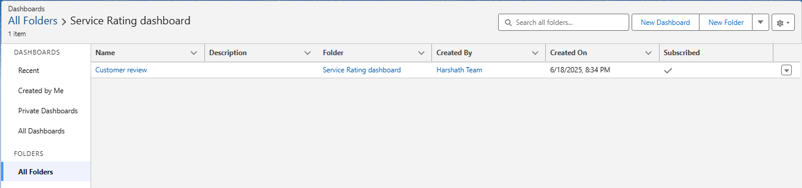

**I. User Profiles and Permission Management**

**Overview:**

Profiles in Salesforce determine the level of access and control that a user has over various features and data within the organization. They define permissions related to:

* Object-level access (e.g., ability to view, create, edit, delete Customer records)
* Field-level access (e.g., whether a user can see or edit a specific field like Total_Amount__c on an Invoice)
* Tab and App visibility (e.g., whether the "Parts Inventory" tab is visible to a Mechanic)
* Apex class and Visualforce page access
* Record Types, Page Layouts
* Login hours and IP restrictions

To ensure data security and task-based functionality for different users in the **Garage Management System**, standard and custom profiles are configured to align with specific roles.

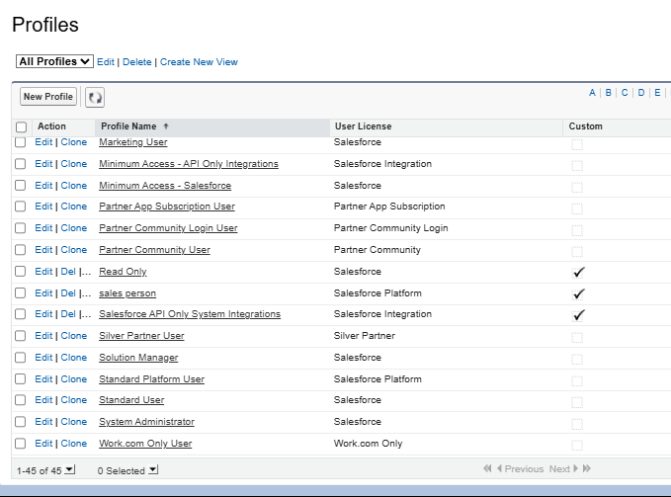

#### A. Types of Profiles in Salesforce

1. **Standard Profiles** (Predefined, cannot be deleted):
   * System Administrator
   * Standard User
   * Read Only
   * Marketing User
   * Contract Manager
   * Solutions Manager

These come with default permissions and are typically used for basic or administrative users, providing a baseline for access.

1. **Custom Profiles** (User-defined, can be deleted if not in use): Custom profiles are often created to align precisely with organizational roles such as **Service Advisor**, **Mechanic**, or **Parts Manager** within a garage environment. These profiles are tailored to provide granular, role-based access control, ensuring users only see and interact with the data and functionalities relevant to their specific job responsibilities.

#### B. User Creation and Assignment

**Purpose:** Creating user accounts in Salesforce allows employees to log in, access the Garage Management System, and perform their daily tasks according to their assigned permissions. Each user account specifies login credentials, personal information, and crucial access settings via their assigned Role, User License, and Profile.

**Instructions for Creating Users:**

1. Go to **Setup** (the gear icon in the top right).
2. In the **Quick Find** box, type "Users" and select **"Users"** under Administration.
3. Click **"New User"**.

**User 1: Manager**

* + **First Name:** Niklaus
  + **Last Name:** Mikaelson
  + **Alias:** (Auto-populate or create one, e.g., NMikael)
  + **Email id:** (Provide your personal email ID for testing)
  + **Username:** (Ensure it's unique, e.g., niklaus.mikaelson@yourgaragem.com)
  + **Nick Name:** (Auto-populate or create one, e.g., NiklausM)
  + **Role:** Manager
  + **User License:** Salesforce
  + **Profile:** Manager
  + Click **"Save"**.

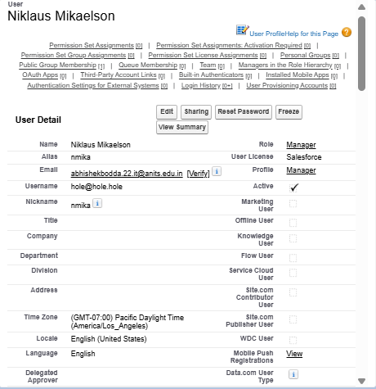

**Creating Additional Users:** Repeat the steps above (Go to Setup > Users > New User) to create at least **3 additional users** with the following permissions. Ensure each user has a unique Username and Nick Name, and provide a valid Email ID for testing purposes.

**Additional User Type: Sales Person**

* + **Role:** Sales Person
  + **User License:** Salesforce Platform (This license typically provides access to custom objects and apps, suitable for a Sales Person role that might not need full standard CRM features)
  + **Profile:** Sales Person

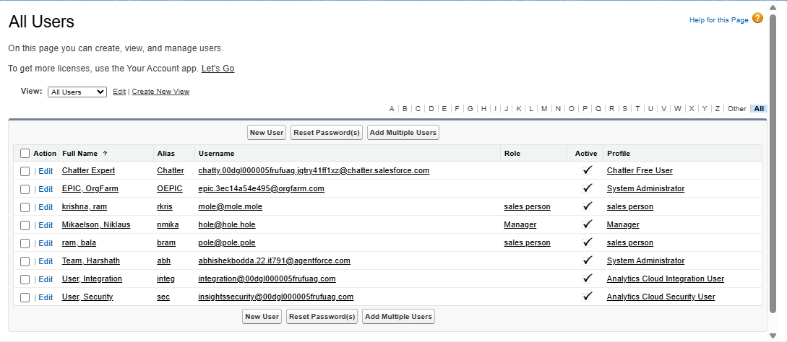

**C. Implementation Activities**

### I. Manager Profile Configuration

**Overview:** Creating a custom "Manager Profile" is a fundamental step in establishing robust security and access control within your Salesforce-based Garage Management System. By cloning a standard profile and customizing it, we ensure that managers have the necessary permissions to oversee all operations, access comprehensive data, and manage key processes, while adhering to specific security policies like session timeout and password expiration.

#### Steps to Create and Configure the Manager Profile:

1. **Create New Profile (Clone Standard User):**
   * Go to **Setup** (the gear icon).
   * In the **Quick Find** box, type "Profiles" and click on **"Profiles"** under Users.
   * Locate the **"Standard User"** profile (or another suitable base profile if preferred for your org's setup).
   * Click on the **"Clone"** link next to the "Standard User" profile.
   * Enter the **Profile Name** as "**Manager**".
   * Click **"Save"**.
2. **Edit Profile Settings:**
   * After saving the new "Manager" profile, you will automatically be directed to its detail page. Click the **"Edit"** button.
3. **Set Default Custom App:**
   * Scroll down to the **"Custom App Settings"** section.
   * Locate the **"Garage Management"** custom app.
   * Select the **"Default"** checkbox next to it. This ensures that when users assigned this profile log in, they automatically land in the Garage Management System application.
4. **Configure Custom Object Permissions:**
   * Scroll down to the **"Custom Object Permissions"** section.
   * For the following custom objects, grant **full access** (Read, Create, Edit, Delete, and potentially View All/Modify All if appropriate for a Manager role):
     + **Appointment__c**
     + **Billing_details_and_feedback__c**
     + **Service_Record__c**
     + **Customer__c**
     + **(Ensure all other relevant custom objects, like Vehicle__c, WorkOrder__c, PartsInventory__c, also have appropriate access for a Manager)**
5. **Adjust Session Settings:**
   * Scroll down to the **"Session Settings"** section (often located towards the bottom, or under System Permissions depending on Salesforce version).
   * Find "Session Timeout" or "Timeout Value".
   * Change the "Timeout Value" or "Session times out after" setting to "**8 hours of inactivity**".
6. **Configure Password Policies:**
   * Scroll down to the **"Password Policies"** section.
   * Set **"User passwords expire in"** to "**Never expires**". (Note: While convenient for testing/development, "Never expires" is generally not recommended for production environments due to security best practices).
   * Set **"Minimum password length"** to "**8**".
   * Click **"Save"** at the top or bottom of the page to apply all changes to the Manager profile.

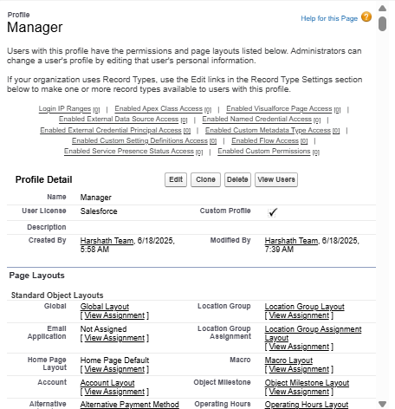

### II. Sales Person Profile Configuration

**Overview:** The "Sales Person Profile" is designed to provide users focused on initial customer engagement, appointment scheduling, and basic customer/vehicle record management with the precise level of access they need within the Garage Management System. This profile ensures that sales personnel (who might function more like Service Advisors in this context) can perform their core duties without access to sensitive administrative functions or full financial data, thereby maintaining data security and operational focus.

#### Steps to Create and Configure the Sales Person Profile:

1. **Create New Profile (Clone Salesforce Platform User):**
   * Go to **Setup** (the gear icon).
   * In the **Quick Find** box, type "Profiles" and click on **"Profiles"** under Users.
   * Locate the **"Salesforce Platform User"** profile. This license/profile combination is often suitable for users who primarily interact with custom applications and objects, like those built for a Garage Management System.
   * Click on the **"Clone"** link next to the "Salesforce Platform User" profile.
   * Enter the **Profile Name** as "**Sales Person**".
   * Click **"Save"**.
2. **Edit Profile Settings:**
   * After saving the new "Sales Person" profile, you will be directed to its detail page. Click the **"Edit"** button.
3. **Set Default Custom App:**
   * Scroll down to the **"Custom App Settings"** section.
   * Locate the **"Garage Management"** custom app.
   * Select the **"Default"** checkbox next to it. This ensures that users assigned this profile automatically enter the Garage Management System application upon login.
4. **Configure Custom Object Permissions:**
   * Scroll down to the **"Custom Object Permissions"** section.
   * For the following custom objects, grant access permissions that align with a sales person's typical responsibilities in a garage (focused on customer interaction, scheduling, and initial record creation, with limited access to sensitive data):
     + **Appointment__c:** Grant **Read** and **Create** access. **Edit** may also be granted if they manage rescheduling, but **Delete** should typically be restricted.
     + **Billing_details_and_feedback__c:** Grant **Read** access. Sales persons might need to view billing history but should generally not be able to create or edit billing details.
     + **Service_Record__c:** Grant **Read** access. They need to see past service history for customer context but don't create or edit these completed records.
     + **Customer__c:** Grant **Read**, **Create**, and **Edit** access. This is crucial for managing customer information. **Delete** should typically be restricted.
     + **(Ensure other relevant custom objects, like Vehicle__c and ServiceRequest__c, also have appropriate access for a Sales Person, typically Read/Create/Edit)**
5. **Save Profile Changes:**
   * Click **"Save"** at the top or bottom of the page to apply all changes to the Sales Person profile.

(Note: The provided instructions did not specify changes to session timeout or password policies for the "Sales Person" profile. Therefore, these settings would remain at their default values for the cloned "Salesforce Platform User" profile, or would need to be explicitly configured if different from the default.)

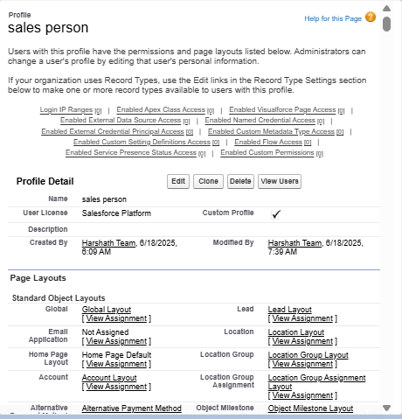

**D. Role Hierarchy and Record-Level Access Control**

**Overview:** In Salesforce, a **Role** defines a user's record-level visibility access, determining which records a user can see based on their position in the organizational hierarchy. Unlike Profiles, which control object and field access, Roles primarily focus on data visibility (e.g., a manager can see all records owned by their subordinates). Setting up a **Role Hierarchy** is crucial for implementing data sharing rules that ensure users have appropriate access to data within the Garage Management System, promoting collaboration while maintaining data security.

#### A. Creating the Manager Role

**Purpose:** The "Manager" role will sit below the top-level (e.g., CEO) and will serve as a supervisory role. Users assigned this role will typically have visibility into records owned by users in roles below them in the hierarchy (e.g., Sales Persons, Mechanics, Parts Managers).

**Steps:**

1. **Navigate to Role Setup:**
   * Go to **Setup** (the gear icon).
   * In the **Quick Find** box, search for "Roles" and click on **"Roles"** under Users.
   * Click on the **"Set Up Roles"** button (if it's your first time setting up roles).

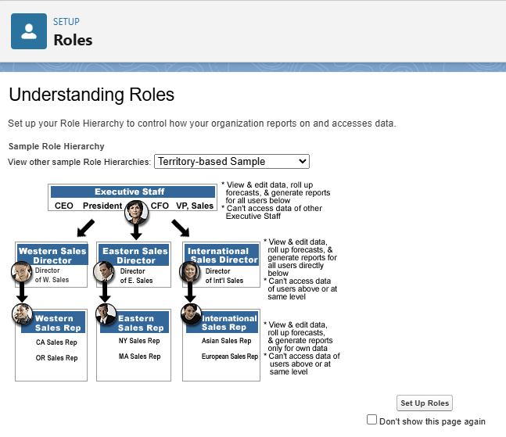

1. **Add Manager Role under CEO:**
   * On the Role Hierarchy page, click **"Expand All"** to view the entire hierarchy.
   * Locate the top-level role (typically "CEO" or your organization's highest role).
   * Click on the **"Add Role"** link directly below the "CEO" role (or whichever role you want the Manager to report to).
   * Give the **Label** as "**Manager**".
   * The **Role Name** will auto-populate (e.g., Manager).
   * Click **"Save"**.

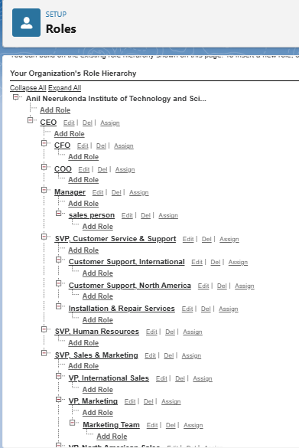

#### B. Creating Additional Roles (Sales Person)

**Purpose:** The "Sales Person" role will be placed directly under the "Manager" role. Users assigned to this role will typically own their individual customer, appointment, and service request records, and their manager will have visibility into these records.

**Steps:**

1. **Navigate to Role Setup (if not already there):**
   * Go to **Setup** (the gear icon).
   * In the **Quick Find** box, search for "Roles" and click on **"Roles"** under Users.
2. **Add Sales Person Role under Manager:**
   * On the Role Hierarchy page, ensure you see the "Manager" role you just created.
   * Click on the **"Add Role"** link directly below the "**Manager**" role.
   * Give the **Label** as "**Sales Person**".
   * The **Role Name** will auto-populate (e.g., Sales_Person).
   * Click **"Save"**.

**(Note: You would repeat this process for any other roles in your Garage Management System, such as "Mechanic" or "Parts Manager," placing them appropriately within the hierarchy, typically under the "Manager" role, or a more specialized supervisor role if your hierarchy is deeper.)**

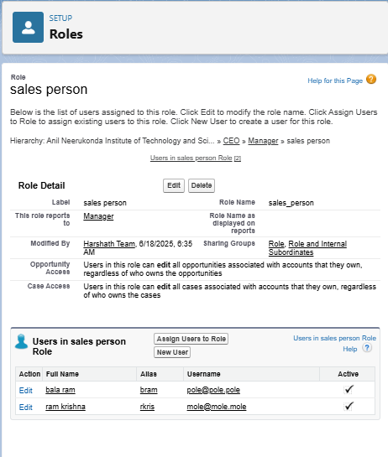

### E. Sharing Settings Configuration

**Overview:** Salesforce allows you to configure sharing settings to control how records are accessed and shared within your organization. These settings are crucial for maintaining data security and privacy by defining the baseline access and then selectively extending it based on organizational structure and specific business needs. Salesforce provides a variety of tools and mechanisms to define and enforce sharing rules, such as:

* **Organization-Wide Default (OWD) Settings:** These settings define the default level of access for all records of a specific object within your Salesforce org. OWD settings include Private, Public Read-Only, Public Read/Write, and Controlled by Parent. They can be configured for each standard and custom object, forming the most restrictive baseline.
* **Role Hierarchy:** Salesforce uses a role hierarchy to determine record access. Users at higher levels in the hierarchy (e.g., a Manager) automatically have greater access to records owned by or shared with users lower in the hierarchy (e.g., Sales Persons, Mechanics). The role hierarchy is often used in combination with OWD settings to grant different levels of access.
* **Profiles and Permission Sets:** Profiles and permission sets allow administrators to specify object-level (e.g., Read, Create, Edit, Delete on an object) and field-level permissions (e.g., visibility or editability of individual fields) for users. Profiles are typically used to grant general object and field access, while permission sets can be used to extend those permissions to specific users or groups without changing their profile.
* **Sharing Rules:** Sharing rules are used to extend access to records beyond what is granted by OWDs and the role hierarchy, for users who meet specific criteria. They can be used to grant read-only or read-write access to records owned by other users, based on group membership, roles, or criteria on the record itself.
* **Manual Sharing:** Administrators and individual record owners (if granted permission) can manually share specific records with other users, roles, or public groups. This is typically used for ad-hoc sharing of individual records.

#### A. Configuring Organization-Wide Defaults (OWD)

**Purpose:** Setting the OWD for Service_Record__c to "Private" ensures that, by default, only the owner of a Service_Record__c record and users higher in the role hierarchy can view or edit that specific record. This establishes the highest level of data privacy for individual service histories, which is a common requirement in sensitive operational data.

**Steps:**

1. Go to **Setup** (the gear icon).
2. In the **Quick Find** box, type "Sharing Settings" and select **"Sharing Settings"** under Security.
3. Click **"Edit"** in the "Organization-Wide Defaults" section.
4. Scroll down to the **Service_Record__c** object.
5. Change its **Default Access** setting to "**Private**" in the dropdown.
6. Click **"Save"**.
7. Acknowledge the warning message (if any) and click **"OK"**. The changes may take a few moments to refresh across the organization.

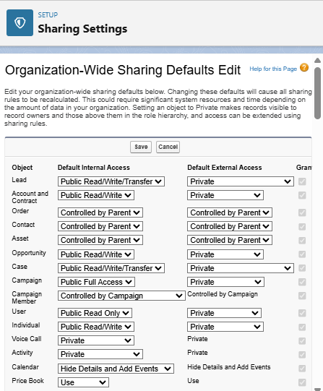

#### B. Creating a Sharing Rule for Service Records

**Purpose:** With Service_Record__c set to Private, users in the "Manager" role would only see records they own or records owned by users directly below them in the hierarchy. This sharing rule will explicitly grant "Manager" roles "Read/Write" access to all Service_Record__c records owned by users in the "Sales Person" role, ensuring managers have comprehensive oversight of service activities initiated by their team members, even if the Sales Person doesn't own the final Service Record.

**Steps:**

1. Go to **Setup** (the gear icon).
2. In the **Quick Find** box, type "Sharing Settings" and select **"Sharing Settings"** under Security.
3. Scroll down to the "Service Record Sharing Rules" section.
4. Click **"New"**.
5. **Step 1: Rule Name & Description**
   * Give the **Label** name as "**Sales Person Service Record Access**" (or "Sharing setting" as per your prompt, but a more descriptive name is better practice).
   * The **Rule Name** will auto-populate (e.g., Sales_Person_Service_Record_Access).
   * Keep "Based on record owner".
6. **Step 2: Select which records to be shared**
   * In the "Select records by owner" dropdown, choose **"Roles"**.
   * In the next dropdown, select "**Sales Person**". This means records owned by users in the Sales Person role.
7. **Step 3: Share with**
   * In the "Share with" dropdown, select **"Roles"**.
   * In the next dropdown, select "**Manager**". This specifies who gains access.
8. **Step 4: Change the access level**
   * Change the **Access Level** for Service_Record__c to "**Read/Write**".
   * Click **"Save"**.

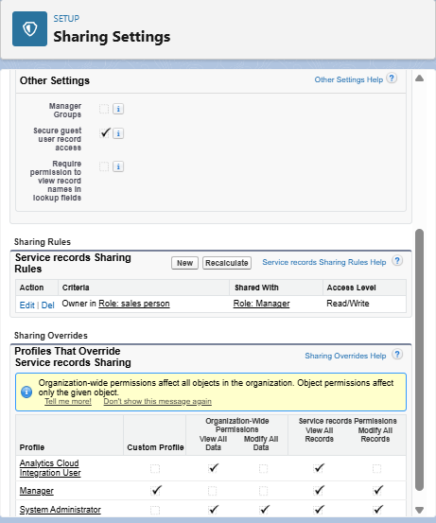

### F. The Lightning App Configuration

**Overview:** A Lightning App is a curated collection of items (such as objects, tabs, and other functionalities) that are bundled together to serve a particular business function. In Lightning Experience, Lightning apps provide users with convenient access to all the tools they need for a specific role or workflow directly within the navigation bar. They allow for custom branding with colors and logos, can include a utility bar for quick access to common tools, and feature Lightning page tabs, enhancing user efficiency by enabling seamless switching between different work contexts.

#### Steps to Create a Lightning App:

1. **Initiate New Lightning App Creation:**
   * Go to **Setup** (the gear icon).
   * In the **Quick Find** box, search for "App Manager" and select **"App Manager"** under User Interface.
   * On the App Manager page, click **"New Lightning App"** in the top right corner.
2. **Define App Details:**
   * **App Name:** Enter "**Garage Management Application**".
   * The Developer Name will auto-populate.
   * (Optionally, upload an App Image and choose a Primary Color for branding).
   * Click **"Next"**.
3. **Configure App Options:**
   * On the "App Options" page, **keep the default settings** (e.g., Navigation Style, Form Factor).
   * Click **"Next"**.
4. **Add Utility Items (Optional):**
   * On the "Utility Items (Desktop Only)" page, **keep it as default** (no utility items will be added unless you configure them here).
   * Click **"Next"**.
5. **Add Navigation Items (Tabs):**
   * This step defines the main tabs that will appear in your app's navigation bar.
   * From the "Available Items" list on the left, select the following items (or search for them if not immediately visible) and use the **arrow button (>)** to move them to the "Selected Items" list on the right:
     + **Customers** (Customer__c)
     + **Appointments** (Appointment__c)
     + **Service Records** (Service_Record__c)
     + **Billing Details and Feedback** (Billing_details_and_feedback__c)
     + **Reports**
     + **Dashboards**
   * You can reorder these items using the up/down arrows if desired.
   * Click **"Next"**.
6. **Assign User Profiles:**
   * On the "Assign Profiles" page, search for **"System Administrator"** in the "Available Profiles" list on the left.
   * Click the **arrow button (>)** to move it to the "Selected Profiles" list on the right. This makes the app visible to System Administrators.
   * **(Note:** You will need to come back and edit this app later to add the "Manager" and "Sales Person" profiles once they are fully configured, to ensure they can also access the app.)
   * Click **"Save & Finish"**.

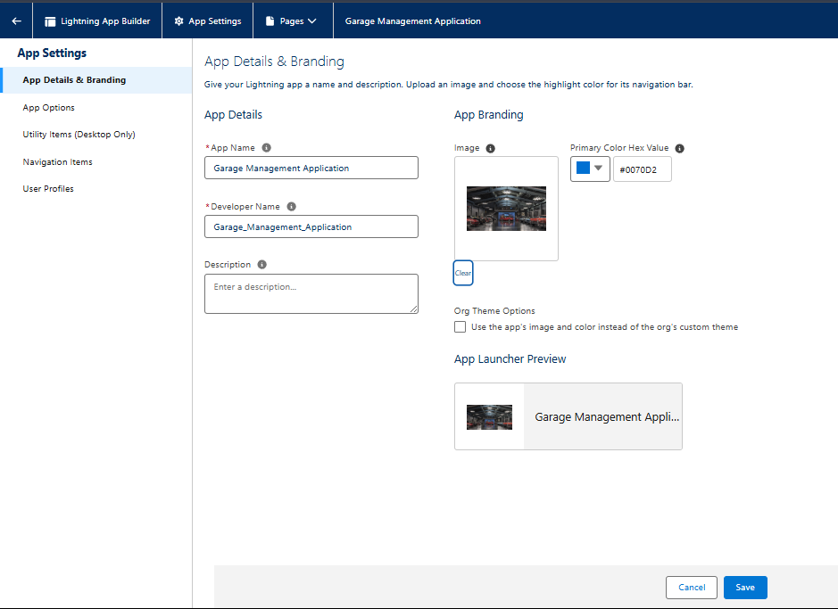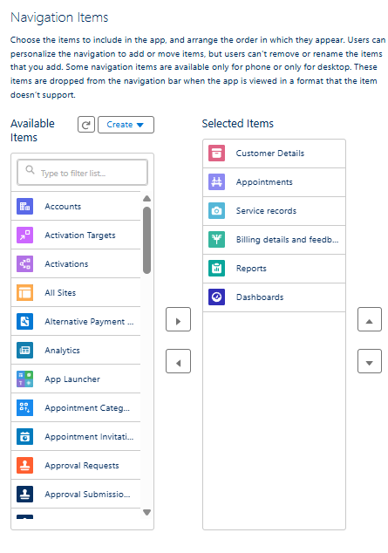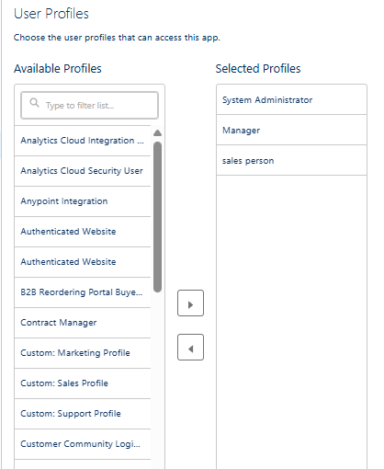

### G. User Adoption - Creating Records

**Overview:** This section provides a practical guide for users to start interacting with the Garage Management System by creating essential records. The goal is to familiarize new users with the system's workflow, data entry forms, and automated processes. By following these steps, users will experience the end-to-end flow of managing a customer, scheduling an appointment, and initiating a service record.

#### Steps to Create Records in the Garage Management Application:

1. **Access the Garage Management Application:**
   * Click on the **App Launcher** (the 3x3 dots icon) located at the left side of the screen.
   * Search for "**Garage Management Application**" and click on it to open the app.
2. **Create a New Customer Record:**
   * Click on the **"Customers"** tab (corresponding to your Customer__c object).
   * Click the **"New"** button.
   * Fill in the customer details as required (e.g., Name, Contact_No__c, Email__c, Address__c).
   * Click **"Save"**.
3. **Create a New Appointment Record:**
   * Click on the **"Appointments"** tab (corresponding to your Appointment__c object).
   * Click the **"New"** button.
   * **Enter Customer Details:** Link this appointment to the Customer__c record you just created using the Customer__c lookup field.
   * **Enter Appointment Date & Time:** Provide a date for the appointment. (Note: The instruction "enter the date less than the created date" is unusual for a real appointment but might be a specific test case for your validation logic. For standard use, enter a future or current date.)
   * **Enter Vehicle Information:** Ensure the Vehicle_number_plate__c (or similar field) matches the validation rule you configured earlier (e.g., "AB01CD2345").
   * **Select Services:** Choose the relevant services required using the Service_Type_Requested__c field (e.g., Oil Change, Brake Service).
   * Click **"Save"**. Observe the Service_Amount__c (if it's a formula field or updated by automation) after saving.

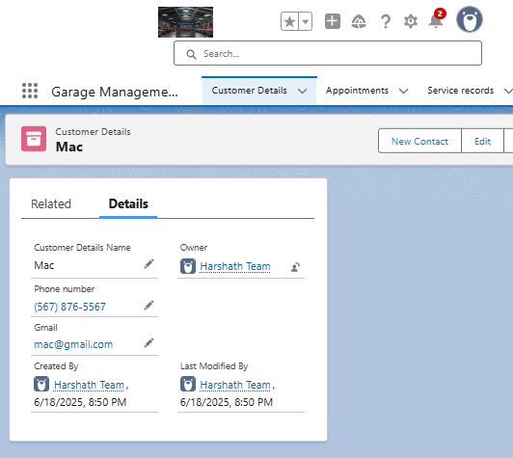

1. **Create a New Service Record:**
   * Click on the **"Service Records"** tab (corresponding to your Service_Record__c object).
   * Click the **"New"** button.
   * **Enter Appointment Details:** Link this service record to the Appointment__c record you just created using the Appointment__c lookup field.
   * Observe that the Started__c status (or similar field indicating work has begun) is automatically selected as default (if configured via automation or default field value).
   * Click **"Save"**.
2. **Update Service Record for Quality Check Completion:**
   * After saving the Service_Record__c, open the record detail page if it's not already open.
   * Locate the **Quality_Check_Status__c** field (or similar field indicating completion of quality checks).
   * Change its value to **"True"** (or mark it as 'Completed').
   * Click **"Save"**.
   * **Observation:** Notice that upon saving, the Service_Status__c (or a similar field like WorkOrder_Status__c on a related object) will automatically update to "**Completed**" (this demonstrates a workflow rule or flow automation at work).